INFORMATION SECURITY SYSTEMS

LAB PRACTICALS RECORD
(CSX - 324)

COMPUTER SCIENCE AND ENGINEERING



DEPARTMENT OF COMPUTER SCIENCE AND ENGINEERING
Dr. B R AMBEDKAR NATIONAL INSTITUTE OF TECHNOLOGY
JALANDHAR – 144011, PUNJAB (INDIA)

Submitted To: Submitted By:
Ms. Deepika Sethi Aman Garg
Asst. Professor 13103050
Department of CSE 6th Semester

INDEX
S. No | Objective | Page No. | Signature
1. | To demonstrate steganography application. | 3
2. | To implement Caesar Cipher. | 7
3. | To implement Playfair Cipher. | 9
4. | To implement Railfence Cipher. | 14

PROGRAM 1
STEGANOGRAPHY
Description:
Steganography is the practice of concealing a file, message, image, or video within another file, message, image, or video. The advantage of steganography over cryptography alone is that the intended secret message does not attract attention to itself as an object of scrutiny. Plainly visible encrypted messages—no matter how unbreakable—arouse interest, and may in themselves be incriminating in countries where encryption is illegal. Thus, whereas cryptography is the practice of protecting the contents of a message alone, steganography is concerned with concealing the fact that a secret message is being sent, as well as concealing the contents of the message.
Steganography includes the concealment of information within computer files. In digital steganography, electronic communications may include steganographic coding inside of a transport layer, such as a document file, image file, program or protocol. Media files are ideal for steganographic transmission because of their large size. For example, a sender might start with an innocuous image file and adjust the color of every 100th pixel to correspond to a letter in the alphabet, a change so subtle that someone not specifically looking for it is unlikely to notice it.

Program:

#include <stdio.h>
#include <stdlib.h>
#include <string.h>
#include <math.h>
#include <assert.h>
#include <ctype.h>

static int byteSize;
#define MAX 1000
#define BITS_CHAR 8
#define input_file "input.txt"
#define crypt_file "updated_input.txt"

void getBinary(char * inp, int * binary){
for (int i = 0; i < strlen(inp); i++) {
int ascii = (int) inp [i];
int counter = BITS_CHAR * (i + 1) - 1;
while (ascii) {
binary[counter] = ascii % 2;
ascii /= 2;
counter -= 1; }}}

void readAndCrypt(int * binary){
// Creates a crypted file from the given input that contain our message
// Here, we denote a binary 0 with a single space and 1 with two spaces.
char myLine[MAX] = {' '};
FILE * fp = fopen(input_file, "r");
FILE* fout = fopen(crypt_file, "w");
int charRead = fread(myLine, sizeof(char), MAX, fp);
int arrayCounter = 0, i = 0;

while (i < charRead && arrayCounter < byteSize) {
if (isspace((int)myLine[i]) && binary[arrayCounter] == 0) {
printf("\nWriting single at %d", i);
fwrite(&myLine[i], sizeof(char), 1, fout);
arrayCounter += 1;
}
else if (isspace((int)myLine[i]) && binary[arrayCounter] == 1) {
printf("\nWriting double at %d", i);
fwrite(&myLine[i], sizeof(char), 1, fout);
fwrite(&myLine[i], sizeof(char), 1, fout);
arrayCounter += 1;
}
else fwrite(&myLine[i], sizeof(char), 1, fout);
i++;
}
fclose(fp);
fclose(fout);
}
void readAndDecrypt(){
// Decrypts information from the updated input file used as a stegnograph
// Converts the result back into the value we want
FILE* fout = fopen(crypt_file, "r");
printf("\n");
assert(fout);

char myLine[MAX] = {' '};
int charRead = fread(myLine, sizeof(char), MAX, fout), i = 0;
int final [MAX] = {0}, finalCounter = 0, ans = 0;

while (i < charRead && finalCounter < byteSize) {
if (isspace((int) myLine[i]) ) {
if ((i + 1) < charRead && isspace((int)myLine[i + 1])) {
printf("\nReading double at %d", i);
final[finalCounter] = 1;
i++;
}
else {
printf("\nReading single at %d", i);
final[finalCounter] = 0;
}
finalCounter += 1;
}
i++;
}
char decrypt[MAX] = {' '};
printf("\n\nReceived the message: \t");

for (int i = 0; i < byteSize; i++) {
if (final [i] == 1)
ans += pow(2, BITS_CHAR - 1 - (i % BITS_CHAR));
if (i > 0 && (i + 1) % BITS_CHAR == 0) {
char sm [2] = {(char) ans,'\0'};
strcat(decrypt, sm);
ans = 0;
}
}
printf("%s\n",decrypt);
}
int main(){
char user_input[MAX];
printf("\nEnter a string to encrypt\t");
fscanf(stdin, "%s",user_input );
byteSize = strlen(user_input)* BITS_CHAR;
int binary[MAX] = {0};
getBinary(user_input, binary);
readAndCrypt(binary);
readAndDecrypt();
return 0;
}
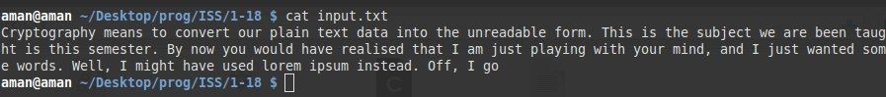
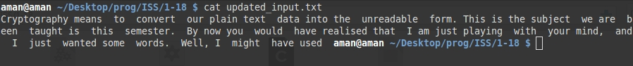
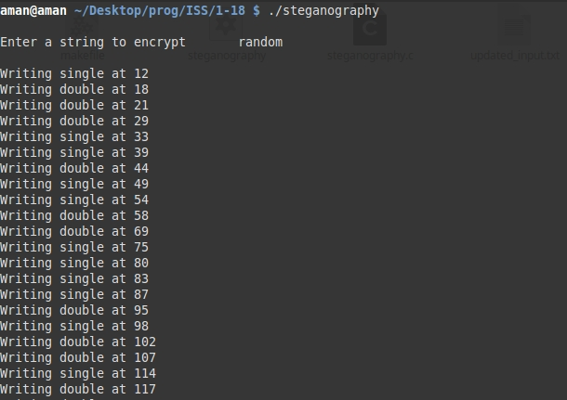

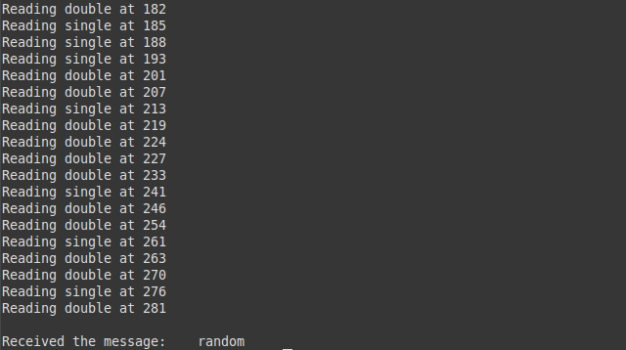

PROGRAM 2
CAESAR CIPHER
Description:
In cryptography, a Caesar cipher, also known as Caesar's cipher, the shift cipher, Caesar's code or Caesar shift, is one of the simplest and most widely known encryption techniques. It is a type of substitution cipher in which each letter in the plaintext is replaced by a letter some fixed number of positions down the alphabet. For example, with a left shift of 3, D would be replaced by A, E would become B, and so on. The method is named after Julius Caesar, who used it in his private correspondence.
The encryption step performed by a Caesar cipher is often incorporated as part of more complex schemes, such as the Vigenère cipher, and still has modern application in the ROT13 system. As with all single alphabet substitution ciphers, the Caesar cipher is easily broken and in modern practice offers essentially no communication security.
Program:
#include <bits/stdc++.h>
using namespace std;
static int substitution_index;

char encrypt(char c){

if (isdigit(c))
return (c -'0' +substitution_index)%10 + '0';

else if (isupper(c))
return char((65 + (int(c) - 65 +substitution_index)%26 ));

else return char((97 + (int(c) - 97 +substitution_index)%26 ));

}

void solve(vector<char> & input){
vector<char>:: iterator it = input.begin();
vector<char> output;

cout<<"\n The Decrypted Message: ";

for(;it!=input.end();it++){
cout<<*it;

if (isalnum(*it))
output.push_back(encrypt(*it));
else
output.push_back(*it);
}

vector<char>:: iterator ot = output.begin();
cout<<"\n The Encrypted Message: ";
for(;ot!=output.end();ot++)
cout<<*ot;

}

int main(){

cout << "\n Enter Key(shift): \t";
cin >> substitution_index;

string s;
cout <<"\n Enter input string: \t";
cin >> s;
vector<char>input (s.begin(), s.end());

solve(input);
cout<<endl<<endl;
return 0;
}

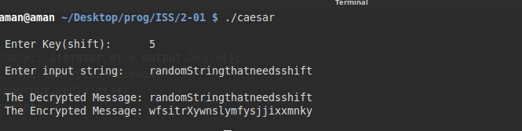

PROGRAM 3
PLAYFAIR CIPHER
Description:
The technique encrypts pairs of letters (digraphs), instead of single letters as in the simple substitution cipher. The Playfair is thus significantly harder to break since the frequency analysis used for simple substitution ciphers does not work with it. Frequency analysis can still be undertaken, but on the 600[1] possible digraphs rather than the 26 possible monographs.
The Playfair cipher uses a 5 by 5 table containing a key word or phrase. Memorization of the keyword and 4 simple rules was all that was required to create the 5 by 5 table and use the cipher.
To generate the key table, one would first fill in the spaces in the table with the letters of the keyword (dropping any duplicate letters), then fill the remaining spaces with the rest of the letters of the alphabet in order (usually omitting "Q" to reduce the alphabet to fit; other versions put both "I" and "J" in the same space). The key can be written in the top rows of the table, from left to right, or in some other pattern, such as a spiral beginning in the upper-left-hand corner and ending in the center. The keyword together with the conventions for filling in the 5 by 5 table constitute the cipher key.
To encrypt a message, one would break the message into digraphs (groups of 2 letters) such that, for example, "HelloWorld" becomes "HE LL OW OR LD", and map them out on the key table. If needed, append a "Z" to complete the final digraph. The two letters of the digraph are considered as the opposite corners of a rectangle in the key table. Note the relative position of the corners of this rectangle. Then apply the following 4 rules, in order, to each pair of letters in the plaintext:
- If both letters are the same (or only one letter is left), add an "X" after the first letter. Encrypt the new pair and continue. Some variants of Playfair use "Q" instead of "X", but any uncommon monograph will do.
- If the letters appear on the same row of your table, replace them with the letters to their immediate right respectively (wrapping around to the left side of the row if a letter in the original pair was on the right side of the row).
- If the letters appear on the same column of your table, replace them with the letters immediately below respectively (wrapping around to the top side of the column if a letter in the original pair was on the bottom side of the column).
- If the letters are not on the same row or column, replace them with the letters on the same row respectively but at the other pair of corners of the rectangle defined by the original pair. The order is important – the first letter of the encrypted pair is the one that lies on the same row as the first letter of the plaintext pair.
To decrypt, use the INVERSE (opposite) of the last 3 rules, and the 1st as-is (dropping any extra "X"s (or "Q"s) that do not make sense in the final message when finished).
Program:
#include <bits/stdc++.h>
#include <iostream>
using namespace std;

#define MAT_SIZE 8
#define inputFile "input.txt"
char * mat[MAT_SIZE];

void build_matrix(string &s1, char ** mat){
for(int i = 0 ; i<MAT_SIZE; i++)
mat[i]= new char[MAT_SIZE];

for(int i = 0; i<MAT_SIZE; i++)
for(int j = 0; j<MAT_SIZE; j++)
mat[i][j] = '!';

set<char> unique;
for(int i = 0; i<s1.size(); i++)
unique.insert(s1[i]);

set<char>::iterator sit = unique.begin();
int last_row, last_col;
bool over = false;

for(int i = 0; i<MAT_SIZE; i++){
for(int j = 0; j<MAT_SIZE; j++)
if (sit != unique.end()){
mat[i][j] = *sit;
sit++;
}
else{
last_col = j;
last_row = i;
over = true;
break;
}
if (over)break;
}
vector<char>not_added_lower;
for(char x = 'a'; x <= 'z'; x++)
if (find(unique.begin(), unique.end(), x) == unique.end())
not_added_lower.push_back(x);

for(int i = 0; i<not_added_lower.size(); i++){
if ((last_col) % MAT_SIZE == 0){
last_row += 1;
last_col = 0;
mat[last_row][last_col++] = not_added_lower[i];
}
else mat[last_row][last_col++] = not_added_lower[i];
}

void encrypt(char a, char b, vector<char>& outputA, vector<char>& outputB){
int x1, x2, y1, y2;

for(int i = 0; i<MAT_SIZE; i++)
for(int j = 0; j<MAT_SIZE; j++)
if (mat[i][j] == a){
x1 = i;
y1 = j;
break;
}

for(int i = 0; i<MAT_SIZE; i++)
for(int j = 0; j<MAT_SIZE; j++)
if (mat[i][j] == b){
x2 = i;
y2 = j;
break;
}
if (x1 == x2){
outputA.push_back(mat[x1][(y1+1) % MAT_SIZE]);
outputB.push_back(mat[x2][(y2+1) % MAT_SIZE]);
}

else if (y1 == y2){
outputA.push_back(mat[(x1+1) % MAT_SIZE][y1]);
outputB.push_back(mat[(x2+1) % MAT_SIZE][y2]);
}
else{
outputA.push_back(mat[x2][y1]);
outputB.push_back(mat[x1][y2]);
}
}
void decrypt(char a, char b, vector<char>& inputA, vector<char>& inputB){
int x1, x2, y1, y2;
if (x1 == x2){
inputA.push_back(mat[x1][(y1 - 1) % MAT_SIZE]);
inputB.push_back(mat[x2][(y2 - 1) % MAT_SIZE]);
}
else if (y1 == y2){
inputA.push_back(mat[(x1 - 1) % MAT_SIZE][y1]);
inputB.push_back(mat[(x2 - 1) % MAT_SIZE][y2]);
}

else{
inputA.push_back(mat[x2][y1]);
inputB.push_back(mat[x1][y2]);
}

}

void solve(vector<char> & inputA, vector<char> & inputB){
vector<char>:: iterator it = inputA.begin();
vector<char>:: iterator it2 = inputB.begin();
vector<char> outputA, reoutA;
vector<char> outputB, reoutB;

cout << "\n The Digraph Message: ";

for(;it != inputA.end();it++, it2++){
cout << *it << *it2 << " ";
encrypt(*it, *it2, outputA, outputB);
}

cout << "\n The Encrypt Message: ";
for(int i = 0; i < outputA.size(); i ++){
cout << outputA[i] << outputB[i] << " ";
}

cout << "\n The Decrypt Message: ";
for(int i = 0; i < outputA.size() -1; i ++)
decrypt(outputA[i], outputB[i], reoutA, reoutB);

it = reoutA.begin();
it2 = reoutB.begin();
for(;it != reoutA.end(); it++, it2++)
cout << *it << *it2 << " ";
}

void consoleInput(vector<char> & inputA, vector<char> &inputB){
ifstream inf(inputFile);
char c, i1, i2;
while((c = inf.get())!= EOF){
if(!isalnum(c))
continue;
i1 = c;
i2 = inf.get();
while(!isalnum(i2) && i2 != EOF)
i2 = inf.get();

if(i1 == i2){
inputA.push_back(i1);
inputB.push_back('!');
inputA.push_back('!');
inputB.push_back(i2);
}
else{
inputA.push_back(i1);
if (i2 == EOF)
inputB.push_back('!');
else inputB.push_back(i2);
}
}
inf.close();
}
int main(){
string s1;
cout << "\n Enter key string for the matrix: ";
cin >> s1;
build_matrix(s1, mat);
vector <char> inputA, inputB;
consoleInput(inputA, inputB);

solve(inputA, inputB);
cout<< endl << endl;
return 0;
}
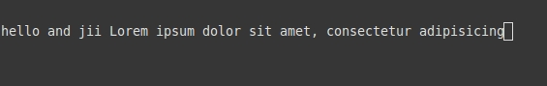

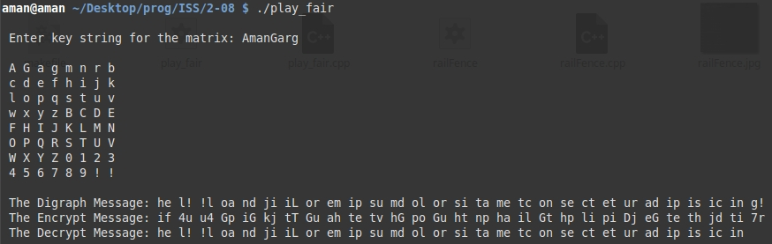

PROGRAM 4
RAIL FENCE CIPHER
Description:
Rail Fence Cipher (also called a zigzag cipher) generally refers to a form of transposition cipher. It derives its name from the way in which it is encoded.In the rail fence cipher, the plaintext is written downwards and diagonally on successive "rails" of an imaginary fence, then moving up when we reach the bottom rail. When we reach the top rail, the message is written downwards again until the whole plaintext is written out. The message is then read off in rows. For example, if we have 3 "rails" and a message of 'WE ARE DISCOVERED. FLEE AT ONCE', the cipherer writes out:
W . . . E . . . C . . . R . . . L . . . T . . . E
. E . R . D . S . O . E . E . F . E . A . O . C .
. . A . . . I . . . V . . . D . . . E . . . N . .
Then reads off to get the ciphertext:
WECRL TEERD SOEEF EAOCA IVDEN

Program:
#include <bits/stdc++.h>
using namespace std;

int numRails;
string userStr;
vector<char> rail;

void display(vector<char> &rail){
cout <<"\n Rail: ";
for (auto a : rail)
cout << a << " ";
cout << endl;
}

void encrypt(){
rail.resize(0);
int starter, gap;
cout <<"\n********ENCRYPTION**********\n";

for (int railNum = 0; railNum < numRails; railNum++){
if (railNum == 0 || railNum == numRails -1){
starter = railNum;
gap = 2 * (numRails -1);
rail.push_back(userStr[starter]);

starter += gap;
while (starter < userStr.size()){
rail.push_back(userStr[starter]);
starter += gap;
}
}

else{
bool isOdd = true;
starter = railNum;
int railBelow, railAbove;
while (starter < userStr.size()){
rail.push_back(userStr[starter]);

if (isOdd){ //do odd first
isOdd = false;
railBelow = numRails - railNum -1;
gap = 2 * railBelow;
}
else{
railAbove = railNum;
gap = 2 * railAbove;
isOdd = true;
}
starter += gap;
}
}
display(rail);
}
}

void decrypt(){
vector<char> deRail(rail.size(),'-');
int i = 0, starter, gap, j;
cout <<"\n********DECRYPTION**********\n";

for (int iter = 0; iter < numRails; iter++){
if (iter == 0 || iter == numRails -1){
starter = iter;
deRail[starter] = rail[i ++];
gap = 2 * (numRails -1);
starter += gap;

while(starter < rail.size()){
deRail[starter] = rail[i ++];
starter += gap;
}
}
else{
bool isOdd = true;
starter = iter;

while (starter < deRail.size()){
if (isOdd){
gap = 2 * (numRails - iter -1);
deRail[starter] = rail[i++];
isOdd = false;
starter += gap;
}
else{
isOdd = true;
deRail[starter] = rail[i++];
gap = 2 * iter;
starter += gap;
}
}
}
display(deRail);
}

}

int main(){

cout <<" Enter String: ";
cin >> userStr;
cout <<" Enter number of rails: ";
cin >> numRails;

encrypt();
decrypt();

return 0;
}

